HOLY WEEK – HOLY SATURDAY
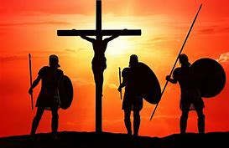

“The Sabbath Day”

Biblical Readings:

- Ecclesiastes 1: 11 (Vanity of Vanities)
- Ecclesiastes 3: 1-8 (There is an appointed time for everything)
- Jn 17: 1-26

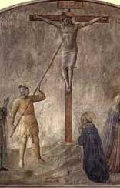
To make sure that Jesus truly died, a Roman guard thrust his lance into his side. The sharp head of the lance hit Jesus’ heart and blood and water flowed out of the pierced wound.

After that Jesus was taken down from the cross and he was buried in a new tomb hewn out of the rock.

In my reflections, I could not see any other disciples standing by the cross, but John. Of course, Jesus’ mother was there together with her sister Mary and Mary of Magdala (Jn 19: 25). The disciples disappeared because (1) they were afraid of the Jews and (2) also their hope to govern Israel had been thrashed through Jesus’ death. With no more hope, why stay?

The disciples went home and tried to forget the ONE they had followed. They felt sad and had pity for Jesus. He had been a powerful man but had died miserably. Peter felt guilty and ashamed when he denied Jesus three times. He cried a lot. Although his hope in the promise of Jesus’ might was dashed, he knew he shouldn’t have denied him. However, there was still some belief in Peter’s feeling about the power of Jesus - like a flickering light in the forest or like a ray of light at the end of a tunnel. If Jesus was not a powerful man, he could not have predicted or foreseen that Peter would deny him three times as he said. Peter thought of this, but had lost hope! Jesus was dead, anyway!

Time went on ... Three days after Jesus’ death, other people in Israel seemed to be enjoying life on the Sabbath Day ...
Asking for a Grace:

Lord Jesus,
At times, like Peter, I have denied you not only three times, but many times.
At times, like the disciples, I have run away from you and have been afraid of letting people know that I am your disciple.
Grant that I become a strong man of faith and a courageous priest in proclaiming your Good News of Salvation for the world.
Amen.

